Mid-Point Circle Drawing Algorithm When Center (0, 0)

- // Mid Point Circle Drawing Algorithm
- // Shafin Ahmed 232-15-184 65-M1
- // For Center (0,0)
- #include <GL/gl.h>
- #include <GL/glut.h>
- #include <stdio.h>

- int r;

- void init()
- {
- glClearColor(0,0,0,0);

- glMatrixMode(GL_PROJECTION);
- glLoadIdentity();

- glOrtho(-100,100,-100,100,-1,1);
- }

- void display()
- {
- glClear(GL_COLOR_BUFFER_BIT);

- glColor3f(0, 255, 255);

- glBegin(GL_POINTS);

- int x = 0;
- int y = r;
- int p = 1 - r;
- while (x <= y)
- {
- glVertex2i( x, y);
- glVertex2i( y, x);
- glVertex2i( y, -x);
- glVertex2i( x, -y);
- glVertex2i(-x, -y);
- glVertex2i(-y, -x);
- glVertex2i(-y, x);
- glVertex2i(-x, y);

- if (p < 0)
- {
- x = x + 1;
- p = p + 2 * x + 1;
- }
- else
- {
- x = x + 1;
- y = y - 1;
- p = p + 2 * x + 1 - 2 * y;
- }
- }

- glEnd();

- glFlush();
- }

- int main(int argc,char** argv)
- {
- printf("Enter Radius : ");
- scanf("%d",&r);

- glutInit(&argc,argv);

- glutInitDisplayMode(GLUT_SINGLE|GLUT_RGB);

- glutInitWindowSize(600,600);

- glutCreateWindow("Midpoint Circle by Shafin Ahmed 232-15-184 65-M1");

- init();
- glutDisplayFunc(display);

- glutMainLoop();

- return 0;
- }

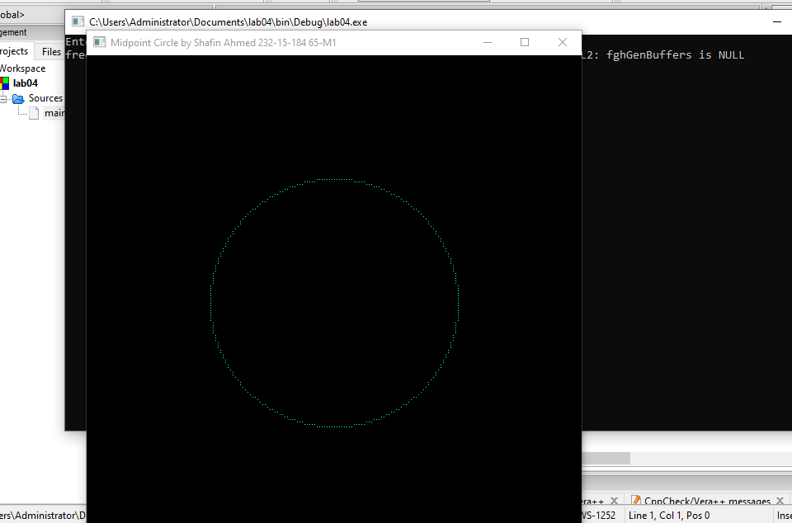

Mid-Point Circle Drawing Algorithm When Center (xc, yc)

// Mid Point Circle Drawing Algorithm
// Shafin Ahmed 232-15-184 65-M1
// For Center (xc,yc)

#include <GL/gl.h>
#include <GL/glut.h>
#include <stdio.h>

int r;
int xc, yc;

void init()
{
glClearColor(0,0,0,0);

glMatrixMode(GL_PROJECTION);
glLoadIdentity();

glOrtho(-100,100,-100,100,-1,1);
}

void display()
{
glClear(GL_COLOR_BUFFER_BIT);

glColor3f(0, 255, 255);

glBegin(GL_POINTS);

int x = 0;
int y = r;
int p = 1 - r;
while (x <= y)
{
glVertex2i( xc + x, yc + y);
glVertex2i( xc + y, yc + x);
glVertex2i( xc + y, yc - x);
glVertex2i( xc + x, yc - y);
glVertex2i( xc - x, yc - y);
glVertex2i( xc - y, yc - x);
glVertex2i( xc - y, yc + x);
glVertex2i( xc - x, yc + y);

if (p < 0)
{
x = x + 1;
p = p + 2 * x + 1;
}
else
{
x = x + 1;
y = y - 1;
p = p + 2 * x + 1 - 2 * y;
}
}

glEnd();

glFlush();
}

int main(int argc,char** argv)
{
printf("Enter Radius : ");
scanf("%d",&r);
printf("Enter Center (X Axis) : ");
scanf("%d",&xc);
printf("Enter Center (Y Axis) : ");
scanf("%d",&yc);

glutInit(&argc,argv);

glutInitDisplayMode(GLUT_SINGLE|GLUT_RGB);

glutInitWindowSize(600,600);

glutCreateWindow("Midpoint Circle by Shafin Ahmed 232-15-184 65-M1");

init();
glutDisplayFunc(display);

glutMainLoop();

return 0;
}

